Mental Health Response Advisory Committee (MHRAC)
Meeting Minutes
October 18, 2022
Via Zoom

Board Members in Attendance
Max Kauffman Disability Right of New Mexico
Cmdr. M. Dietzel Crisis Intervention Division
Mariela Ruiz-Angel Albuquerque Community Safety
David Ley New Mexico Solutions
Gilbert Ramirez CABQ-Dept. of Family & Comm. Services
Betty Whiton NAMI
Laura Nguyen Albuquerque Ambulance
Coty Maxwell Crisis Intervention Division

Introduction to MHRAC
The Mental Health Response Advisory Committee (MHRAC) was created by the Court Approved Settlement Agreement (CASA). We’ve been around since day one and have a focus on three areas, resources, and resources being available to access different things within the city that APD and first responders can use as it impacts homelessness and mental health issues. We are also involved in training and policy; training is one of those things we made a tremendous impact on. As far as the training that is offered. Policies are one of those things where the MHRAC is involved with assisting in writing and approving and recommending policy as it relates again to the narrow focus; we think narrow, but sometimes it gets pretty wide-focused on how law enforcement interacts with those experiencing homelessness and those experiencing a mental health crisis.

Roll Call, Max Kauffman
Eight (8) of the Board Members were present (names listed above)

Welcome first-time guests
Rebecca Frock, Director of Behavioral Health, UNM Sandoval Regional Medical Center

Approval of meeting minutes
1st Motion – David Ley
2nd Motion – Gilbert Ramirez
Minutes from the September meeting were approved by acclamation

Public Comment (Two minutes per person)
None

Nomination of New Board Members, if any, Rachel/Max
No nominations were made

Albuquerque Community Safety Department (ACS) Update, Jasmine Desiderio
Our information and data are available on the ACS Website www.cabq.gov/acs/reports
- We have been in operation for over a year now
- Since last September we’ve seen an increase in calls and the impact we have made here in the City of Albuquerque
- We have responded to over 12,000 calls and 9,000 of those calls have been diverted from APD. Within these numbers will also be the total numbers for the Crisis Respond Team, Mental & Behavioral Health Responders, Community Responders, and Street Outreach Responders
- We have been struggling with a limited amount of staff, especially admin staff. We currently have 15 outside responders coming in to “hopefully” start at the end of October or early November
- We will be having a hiring frenzy; we have been in a push to hire additional responders
- Our next cohort training is going to be provided at the beginning of December; it will be a three-week training, so we will be reaching out to all the folks who have been providing the training for us
- Our responders have different responses to different council districts so we are trying to figure out if it is for ACS benefit or ACS ability to have responders stationed in different areas like APD does. With new responders coming on board, we would be able to keep some units downtown servicing that area. Most of our calls are coming from that area command.
- Starting Monday we are going to have an ACS Trainee Administrator who will be our point of contact (POC). He will reach out to you and talk about metrics and how we can evaluate what is happening in our training. He will be working with APD, particularly in writing different types of lesson plans.
- We are going to have a new Violence Intervention Program that is getting a school base coordinator and will be stationed out of the West Mesa High School. Their job will be the same thing that they do for the City of Albuquerque but targeting it for school.
- HR has had a little hiccup in getting external candidates hired. That has been cleared up and we have been able to process 13 different candidates this past week to get internal promotions as well as fill our admin staff.
- We have a couple of people coming in from the Baltimore Policing Project to do a site visit with us this week.
- ACS is going to be presenting at the National League of Cities next month.

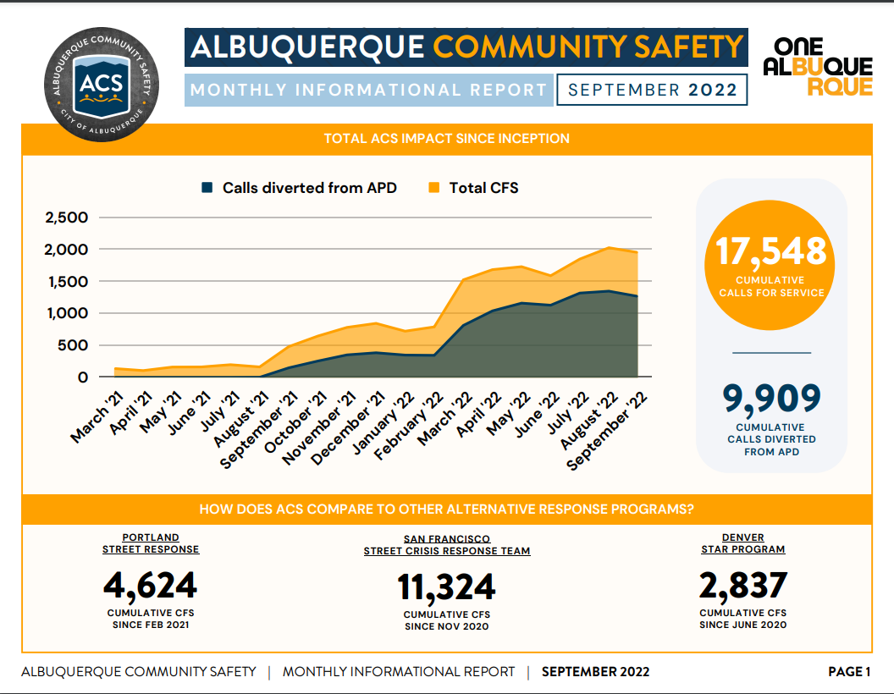
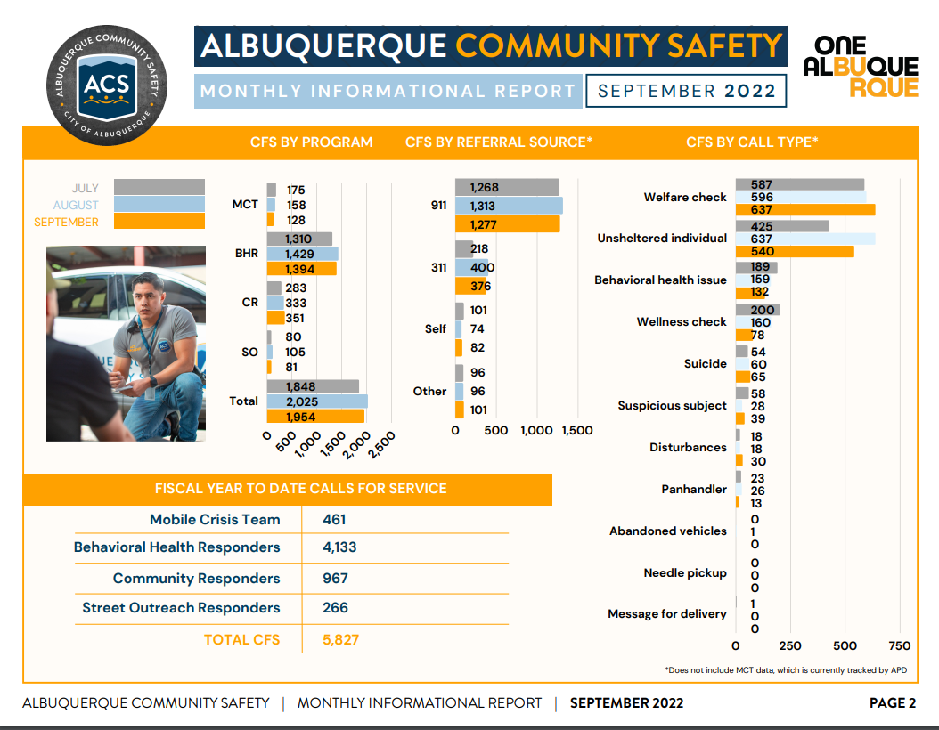

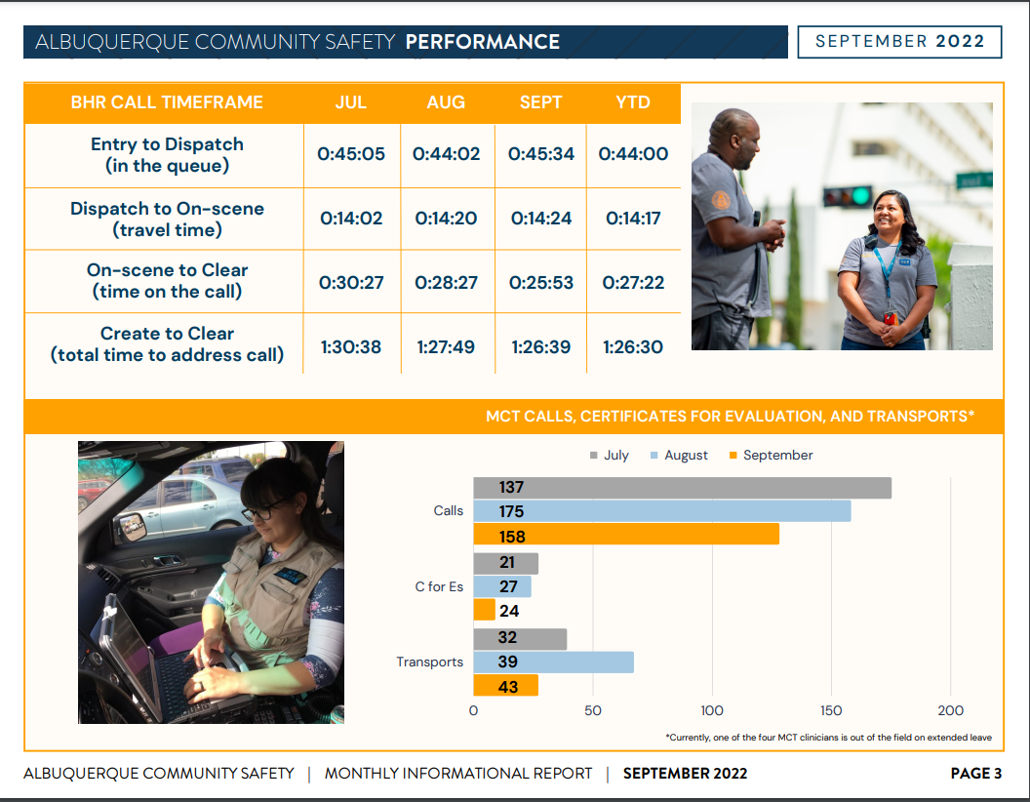
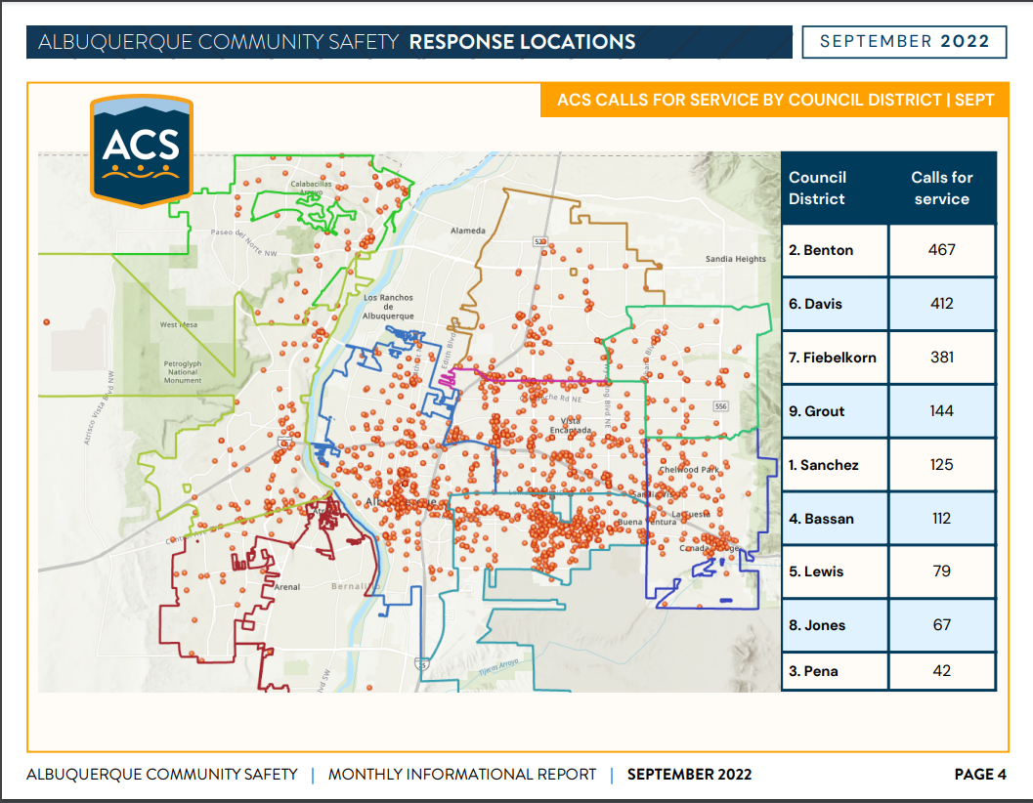

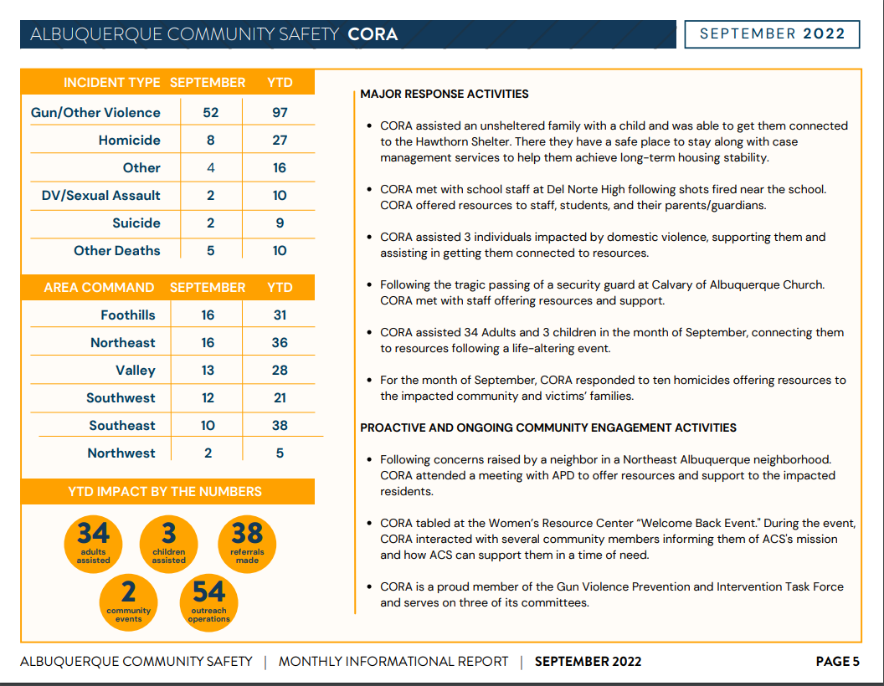
Gibson Health Hub, Family and Community Services, Gilbert Ramirez
- Construction has begun with regard to the Sheltering area as well as our Engagement Center area. We're working closely with the contractor provider who wanted the service there which is Heading Home and our Community Outreach Coordinator to get the right services that are going to be necessary to be facilitated out of the Engagement Center. Despite having the shelters there, we want to have an Engagement Center that will allow providers to be able to hold space there whether it's just a couple hours, a weekend, or multiple days, and we’re making sure those coordinated services are happening.
- Things are moving forward to meet with the first responders to hammer out what the first responder drop off would be like so there is an intentional plan to have a First Responder Drop Off option available
- Policies are going to be developed, once they are drafted they will be brought to MHRAC for review and any kind of input or feedback.
- I'm working on medical sobering, which will also be part of the hub. So the County Commission approved supporting us with $4.35 million in capital to start phase I, so we're extremely appreciative of that collaboration. We have enough money to move forward. Architectural Design and Schematics are moving forward.
- We also had a wonderful meeting with Shannon Barnard, Board President, of National Sobering Collaborative Nationwide; she was able to review our plans and give us some great feedback as to considerations from another sobering center she has seen in the nation and has also agreed to continue to provide us feedback with regards to the services and things we might be missing.
- We already have some operational money that was put in the city council budget. Our next plan will be to get a payout for the provider and the services at the site center.

CIU, APD, and BSS Report and update, Commander Dietzel
- On Tuesday, Sgt. Crook will be promoted to Lieutenant; he is at the top of the Lieutenant list so it is very unlikely that he will be back for another MHRAC meeting.
- Ben Melendrez received Non-uniformed Officer of the Month, essentially Detective of the Month.
- A few of the Home Visit Team went to an Assisted Outpatient Treatment Conference in San Antonio and just got back
- Dr. Rosenbaum presented the ECHO Program at the National Association Chief of Police Conference in Dallas, Texas. I got some feedback from Dallas today talking about what a great job he did.

Lt. Gonzales
Clinician Mike Lucero and Detective Casey Bailey did great with their presentation at the Assisted Outpatient Treatment National Conference. In front of a lot of people, they talked about our relationship and explained a little about our unit, our program, our design, and how we collaborate with AOT.

Mike Lucero
It was a great opportunity to represent the City of Albuquerque, the Albuquerque Police Department, and the Crisis Intervention Unit at a National Conference on Assisted Outpatient Treatment. In the past, we have used that as a resource for the consumers that we are working with to try to improve the quality of life for these folks that we are caring for on a daily bases. It was a great networking opportunity with other providers and other members of law enforcement.

David Ley
Q I am aware that the New Mexico AOT Law is significantly different from similar laws in other states, was there any discussion on that?

Mike Lucero
A. Yes, one of the significant things I noticed is that other states are using the AOT program in Psychiatric Inpatient Units, to funnel people right into that program after they're stabilized and are ready for discharge. That is different from how we implement AOT here in Albuquerque, New Mexico.

3-41 Complaints Involving Department Policy and Personnel, for MHRAC Board Approval, David Ley
David Ley
Q. Are the complaints filed solely for the sworn staff or any department personnel?

Commander Dietzel
A. It is for anyone who is employed with the APD Police Department

David
Q. Are people able to make a complaint anonymously?

Commander Dietzel
A. Yes that was one of the things the settlement agreement did add. Before the settlement agreement was instituted APD was not accepting anonymous complaints. I believe the argument was that they're really hard to investigate, and they are, but we do still accept them now. So anyone can submit a complaint either online to any member of the department. When you go to the police website in the City of Albuquerque site, “complaint,” is one of the first things on there.

Commander Dietzel
I'm looking at the changes here and it looks like a lot of the changes just have to do with the language and where things are located.

David
In the chat, Deirdre noted that as the complaints come to the Civilian Police Oversight Association (CPOA), they include information on whether there are mental health or homelessness issues related to those complaints. She says it's identified in the annual report.

Deirdre Ewing
We collect a lot of demographic information at the bottom of the complaint form; that includes whether or not the individual is experiencing homelessness or if they suffer from any mental health issues. We also collect race information and sexual identity.
We do have our semiannual reports published on our website and that data is usually published in those reports. I will say given my experience, some people do decline to answer some of those questions, particularly the mental health question. But we do our best to collect that data because it is one of those things that the CASA does require that we keep data on.

David
Q. Is there a process that an individual with disabilities, for instance, would have accommodations to be able to file that complaint? Or is it only through the website that they'd be able to access that process?

Commander Dietzel
A. Yes, there are a couple of different ways. Probably the easiest way for someone depending on what their disability is, would be to just approach any APD officer or civilian front office staff. Sometimes their complaints come in through 311 or 242-COPS.

David
I would like to note that we have discussed policy 3-41 Complaints Involving Department Policy and Personnel, and it seemed to be okay.

End-of-Year Annual Report Update
I will start working on the annual report for the Infoshare subcommittee in November, I usually have it ready to go for the December Information-Sharing Sub-committee meeting for everyone to review.
Sub-Committees Report and Updates
Training Sub-Committee – David Ley
- We followed up on the C for E policy that was discussed at the MHRAC big meeting.
- A suggestion was made to the CIU to have APD-CIU put out an informational video or material for behavioral health providers to understand how to issue effective Certificates of Evaluation (C for E’s). This can also help the clinicians understand how they and the officers can communicate about the effectiveness of the C for E.
- We have had some preliminary discussion on our annual report and we will be reviewing a draft of that report at the November meeting
- There were no changes to MHRAC as far as duties, responsibilities, or obligations by the city or APD.

Inforshare Sub-Committee – Commander Dietzel
- 2-85 Certificate for Evaluation policy was discussed
- FCS Encampment policy was discussed
- Will equipment and property be stored and how
- RFP has been submitted and is it going to be accepted
- Albuquerque Community Services gave an update on some of their policies
- Future ideas were given on Resource Cards

MHRAC Final Discussion (5 minutes)
Commander Dietzel
The first six months’ data report on crisis interactions for APD is posted on the MHRAC Website. The link will be posted on the chat and at the next meeting, I will take a few minutes to walk everybody through the slides.

Next meeting: Tuesday, November 15, 2022

